Semi-annual Social Safeguards Monitoring Report
(July to December 2020)

Uzbekistan: Central Asia Regional Economic Cooperation Corridor 2
(Pap-Namangan-Andijan) Railway Electrification Project

Project Number: 48025-003
Loan Number: 3527-UZB
Prepared: February 2021

Prepared by O’zbekiston Temir Yo’llari for the Asian Development Bank.

This Social Safeguards Monitoring Report is a document owned by the borrower. The views expressed herein do not necessarily represent those of ADB’s Board of Directors, Management, or staff. These documents are made publicly available in accordance with ADB’s Public Communications Policy 2011 and as agreed between ADB and the O’zbekiston Temir Yo’llari.
In preparing any country program or strategy, financing any project, or by making any designation of or reference to a particular territory or geographic area in this document, the Asian Development Bank does not intend to make any judgments as to the legal or other status of any territory or area.

ABBREVIATIONS

ADB | Asian Development Bank
AH | Affected Household
AP | Affected Person
CAREC | Central Asia Regional Economic Cooperation
DMS | Detailed Measurement Survey
EA | Executing Agency
GRM | Grievance Redress Mechanism
ha | Hectare
LARP | Land Acquisition and Resettlement Plan
PIU-E | Project Implementation Unit for Electrification
RRJ | Regional Railway Junction
SDDR | Social Due Diligence Report
SES | Socio Economic Survey
SPS | Safeguards Policy Statement
SSMR | Social Safeguards Monitoring Report
TL | Transmission Lines
UTY | O’zbekiston Temir Yo’llari

Table of Contents
Table of Contents 3
1. INTRODUCTION 4
1.1 Overview and Background of the Project 4
1.2 Project Categorization for Involuntary Resettlement 6
1.3 Internal Monitoring Methodology and Scope of the Report 7
2. INSTITUTIONAL ARRANGEMENTS AND CAPACITY BUILDING ACTIVITIES 8
3. COMPONENT 1: ELECTRIFICATION OF THE MAIN TRACK (145.1 KM) 9
3.1 LARP Preparation and Approval 9
3.2 LARP Implementation and Information Disclosure 9
3.3 Design and scope changes and related social due diligence 11
3.4 Next Steps 12
4. COMPONENT 2: CONSTRUCTION OF TWO NEW TRACTION SUBSTATIONS IN NAMANGAN (RAUSTAN AND KHAKKULABAD, INCLUDING THE ACCESS ROADS) 13
4.1 LARP Preparation and Approval 13
4.2 LARP Implementation 14
4.3 Unforeseen Impact 14
5. COMPONENT 3: EXTERNAL POWER SUPPLY TRANSMISSION LINE (TL) OF 52KM 16
5.1 Approval of LARP 2.1 16
5.2 Implementation of LARP 2.1 17
5.3 Preparation and Approval of LARP 2.2 17
5.4 Implementation of LARP 2.2 18
6. COMPONENT 4: ASSOCIATED FACILITIES 19
6.1 Electrification of The 27.5 Kv Transmission Lines for the New Alignment of 6.7 Km 19
6.2 New passing loop at 137km (Uychi Block Post) 20
Annex 1: List of DDR sections under LARP 1 with chainages 22
Annex 2: LAR Impact Summary Data Per Implemented LARPs 22
Annex 3. Summary Status of Safeguards Documentation and Implementation per Project Components 23
Annex 4. Payment Order of Compensation for Registration Cost 24

- INTRODUCTION

Overview and Background of the Project
- The Government of Uzbekistan (the government) has requested Asian Development Bank (ADB) assistance for the electrification of the railway line from Pap to Namangan to Andijan. The project aims to electrify the missing 145.1 kilometers (km) of non-electrified track linking major cities in the populous Fergana Valley with Tashkent. This will facilitate direct and efficient operation of both freight and passenger train services, and thereby promotes economic and social development of the Fergana Valley.
- The Project will be aligned with the following impacts: (i) stimulated economic growth in the Fergana Valley, and (ii) increased regional trade along Central Asia Regional Economic Cooperation (CAREC) Corridor 2. The outcome will be the level of passenger and freight service on the Pap-Namangan-Andijan railway line improved.
- The Project will produce two outputs. First, railway infrastructure along the Pap Namangan-Andijan railway line will be upgraded. This includes electrification of 145.1 km of the main railway line to 27.5 kilovolts alternating current (including the 3.5 km line from Blok Post 136.1 to Uchkurgan), construction of 2 traction substations and dispatcher points, modernization of the locomotive depot in Andijan for it to be able to handle electric locomotives, purchase of maintenance equipment and machinery, modernization of signaling and communications facilities, and construction of external power supply facilities which will transmit electricity from the main grid to the traction substations. Separate to the project and with the financing of the government and O’zbekiston Temir Yo’llari (UTY), work has progressed to realign six kilometers of the railway line to bypass a section of the line that currently traverses the territory of the Kyrgyz Republic: this section is considered an associated facility to the Project, and will subsequently be electrified under the Project. Second, UTY’s institutional capacity will be strengthened, especially with regards to railway safety.
- The Project, for purposes of social safeguards, is organized into the following components:
    - Electrification of the main track (145.1 km) between 5.2 km east of Pap Station and Andijan 1 station, and including the 3.5 km line from Blok Post 136.1 to Uchkurgan- Voltage of transmission lines will be 27.5 kV
    - Construction of two new traction substations in Namangan (Raustan) and Khakkulabad, including the access roads
    - External power supply transmission line (TL) of 52km to transmit electricity to two new substations to be constructed as follows:
      - 110 kV TL for Khakkulabad (40 km)
      - 220 kV TL for Namangan/Raustan (12 km)

- Furthermore, the following component is treated as an associated facility:
    - Construction of the new alignment (6.7 km) – Subsequently this section will also be electrified with Voltage of transmission lines to be 27.5 kV
    - Construction of Uychi Blok post new passing loop at km137 which includes: (i) building of Uychi Blok post, (ii) automobile road for passing loop (780m) and (iii) borrow pit for construction (120m)

Figure 1: Map of the Project Area
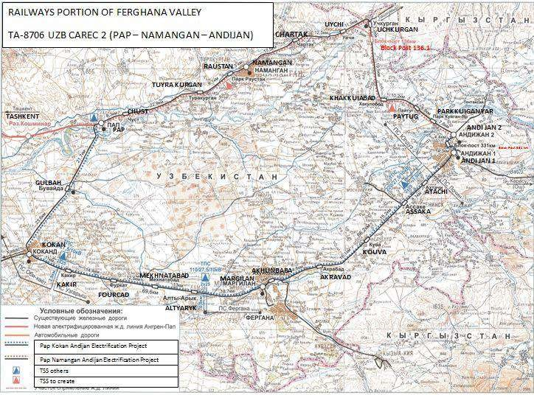

- While the draft LARP has been prepared for all project components (excluding the associated facilities), it is planned to prepare separate final implementation-ready LARPs to ensure the flexibility of project implementation (commencement of civil works) as follows (see also the Figure 2):
    - LARP 1 for main railway track (145.1km), covering also the social due diligence of sections with no LAR impacts (see Annex 1)
    - LARP 2.1 for external power supply in Raustan and LARP 2.2 in Khakkulabad)
    - LARP 3 for two traction substations

- UTY is executing agency (EA) responsible for implementation of the project. A Project Implementation Unit (PIU) is established in UTY which is responsible for the overall land acquisition and resettlement (LAR) activities. The PIU has a designated safeguards specialist who is specialized in safeguards activities and is responsible for ensuring that all the activities related to land acquisition and involuntary are being followed and implemented in accordance with Uzbekistan's legislation and policies and ADB's SPS. The summary LAR impact per implemented LARPs is presented in Annex 2.
Figure 2: Map of the components per social safeguards approach
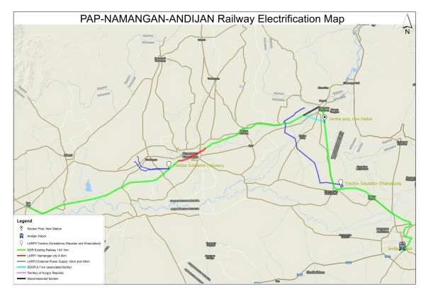

Project Categorization for Involuntary Resettlement
- Land acquisition and involuntary resettlement impacts under the Project are considered as permanent and temporary impacts. Permanent land acquisition includes loss of land permanently required along with its associated assets for the proposed construction of suspension, anchor-angular and tension towers of transmission lines (TLs); for the construction of two new traction substations; as well as permanent impacts on buildings/structures within the safety zone of the ROW of the railway. Temporary land acquisition includes loss of land required temporarily during construction of the suspension, tension and anchor-angular foundation towers which will cause loss of crops/trees due to the construction process, but this will revert to existing occupiers of the land once construction has been completed.
- The project is categorized as “B” for involuntary resettlement in accordance with ADB’s Operation Manual (OM) F1, as it will significantly affect less than 200 APs.
- According to the requirements of the SPS 2009 and established operational practice, the project approval/implementation is based on the following LAR-related conditions:
- Approval of Loan: Conditional to preparation/disclosure of a draft LARP acceptable to ADB and Government of Uzbekistan;
- Project implementation clearance: Conditional to the finalization of the LARP(s) as an implementation-ready document(s) and its disclosure.
- Start of Physical Civil Works: Conditional on full implementation of the final LARP(s) (full compensation/rehabilitation delivery) to be vouched by a Compliance Report (s) prepared by UTY and acceptable to ADB
- Besides, UTY shall also implement the corrective action plan prepared and attached to the Social due diligence report (SSDR) for associated facilities. The summary status of safeguards documentation and implementation per project components are given in Annex 3.

Internal Monitoring Methodology and Scope of the Report
- According to ADB Safeguards Policy Statement (2009) (SPS) each project with involuntary resettlement should have internal monitoring system in place to monitor planning and implementation of the project safeguards component.
- LARPs preparation and implementation is routinely monitored internally by the UTY (PIU) with outcomes reported to ADB in relevant Completion Reports (CR), as well as in Semi-annual Social Monitoring Reports (SSMR).
- This SSMR for Central Asia Regional Economic Cooperation Corridor 2 (CAREC) Pap Namangan-Andijan Railway Electrification Project covers the period from July to January 2020. The objective of the report is to provide an overview of the progress made in the planning and implementation of the land acquisition and resettlement (LAR) tasks in the second half of 2020. It describes the project’s performance in dealing with impacted assets registration/records and compensation processes, and grievances received and redressed.
- The monitoring involves (i) administrative monitoring to ensure that implementation is on schedule and problems are dealt with on a timely basis and (ii) overall monitoring to assess status of affected persons in terms of compensation and assistance and alternate land allocation with land development etc. Monitoring will include daily planning, implementation, feedback and troubleshooting, individual affected person file maintenance, community relationships, dates for consultations, number of appeals placed and progress reports.
- The internal monitoring is being carried out through the following aspects:
- Preparation of LARP(s) and other agreed safeguards documentation for project component and their submission for ADB’s review and approval, tracking the pending issues and initiate actions;
- Progress of implementation of approved LARP(s) and other safeguards-related action plans
- Verification of the compliance with safeguard measures and their progress toward intended outcomes,
- Document and disclose monitoring results and identify necessary corrective and preventive actions in the periodic monitoring reports
- Disclosure and consultation, including the timely disclosure of LARPs and monitoring reports
- Follow up on timely allocation of budget by khokimiyats and/or UTY for LARP implementation as required
- Land for land compensation (land allocation by khokimiyats)
- Disbursement of compensation and assistance
- Grievance resolution
- Notice to proceed for Civil works construction
- Restoration of land
- Overall compliance review and reporting
- Internal monitoring data has been collected through desk review of project documents, consultation and informal interviews with stakeholders and affected people, analysis of grievances, if any, observations during field visits.
- The SSMR will be disclosed on ADB and UTY websites once approved by ADB.
- INSTITUTIONAL ARRANGEMENTS AND CAPACITY BUILDING ACTIVITIES
- Whereas UTY (PIU-ET) currently has one staff to oversee social and environmental safeguards, the concerned staff is overburdened. To strengthen PIU-E capacity on involuntary resettlement, it was decided to enforce the contractual obligations of the PMC. In particular: One international and national resettlement consultants under the Project Management Consultant (Italferr S.P.A.) have been hired through a variation order. The international and national consultants are engaged in the processes during the reporting period.
- Taking into account limitations occurred due to Covid19 to have a face to face meeting, PMC has implemented all LAR related communications between PIU-PMC through the video calls by “Microsoft Teams” set up twice a week per month. Besides, the shared folder access has been provided to the safeguard specialists where all LAR related documents, namely approved SSMRs, Completion reports, current action plans etc. are presented and updated periodically.

- COMPONENT 1: ELECTRIFICATION OF THE MAIN TRACK (145.1 KM)

LARP Preparation and Approval
- The implementation-ready Land Acquisition and Resettlement Plan (LARP) has been prepared for one of the components of the “CAREC Corridor 2 (Pap-Namangan- Andijan) Railway Electrification Project”: electrification of main track (145.1 km) starting from Pap station PK473+63 until Andijan station PK3279+54, Voltage of transmission lines will be 27.5 kV to be financed by the Asian Development Bank (ADB) to assess the land acquisition and resettlement impacts of the project based on the final design. This LARP complies with requirements of relevant Uzbek laws and regulations and ADB’s Safeguards Policy Statement (SPS) of 2009 and is based on the detailed measurement survey (DMS) and Census data which allowed assessing the project’s actual impact. The LARP has been approved by ADB on July 2019 and has been disclosed on ADB’s and UTY’s websites.
- The impact of the project in terms of land acquisition is limited to one city: Namangan. Permanent land acquisition includes loss of in total 85 residential structures and improvements (1,609.87 m²) located on 16 land plots of 16 AHs permanently affected by the Project. Out of 85 affected structures only 2 main residential houses and their adjacent structures and improvements (433.13 m²) located on 2 land plots are fully affected and demolished. 2 AHs have been relocated. The remaining 69 affected structures and improvements (1,176.74 m²) located on 14 land plots are mainly adjacent structures of residential houses which were partly demolished, and the houses were not been relocated. A total of 42 number of trees owned by 3 AHs out of total 16 AHs were affected due to permanent acquisition, of which 27 are fruit trees, 12 wood/decorative trees and 3 bushes. There are only two severely affected households due to permanent land acquisition and physical displacement, as well as total 6 vulnerable AHs affected. The total number of AHs are 16 with total number of 119 APs, out of which 2 AHs (17 APs) were severally affected and 6 AHs (44 APs) were vulnerable AHs.

LARP Implementation and Information Disclosure
- LARP implementation has actually started at the end of July 2019. Prior the LARP implementation, the following preparatory activities were carried out by the UTY (PIU) within the LARP implementation:
- Disclosure of approved LARP on Project’s (UTY’s) website.
- Disclosure of final approved LARP in affected districts via khokimiyats: UTY sent an official letter to Namangan province khokimiyat by indicating the link to the webpage of disclosed final LARP1 in two languages Russian and English for their information and dissemination in affected districts.
- Communication of the compensation data with khokimiyats: Official letters have been sent to khokimiyats with provision of data on compensation packages for each AH defined by LARP.
- Consultations with khokimiyats regarding the allocation of relevant budget and procedures for the compensation delivery (including the land allocation by khokimiyats),
- Preparation of notification letters and face to face notification to each AH regarding the defined compensation amount.
- Preparation of information leaflets for the notifications to each AH.
- The land allocation protocol was issued by khokimiyat of Namangan on 21.05.2019 for 2 physically relocated AHs on provision of 400m² land plot per each AH and for the remaining 14 AHs to be partially acquired. The land allocation in Namangan is regulated by the Resolution of Cabinet of Ministers №63 dated on 28.01.2019 which usually applies to residential areas instead of Resolution of Cabinet of Ministers 272 (30.12.2006 mentioned in LARP, which requires allocation of 600 m² for individual housing. Thus, according to Resolution of Cabinet of Ministers №63 and issued protocol the allocation of land plots for individual residential construction is envisaged in the amount of up to 0.04 hectares.
- In order to present the request to Land Allocation Commission, in assistance of UTY, all the required documents of 2 AHs have been already collected and provided to khokimiyat. After that, the khokimiyat has presented the proposal with several options of the similar lands and has discussed with APs the parameters of the allocated lands, particularly the region and district, distance from the previous place of residence, access to existing infrastructures and public services and etc. Taking into account the reached agreement with APs and revision of legal basis of provided information, the Land Allocation Commission (consisted 6-8 representatives of the different departments of khokimiyat) gave its approval on land allocation based on which Khokim/Governor of the city makes a decision. Based on the decision №460 of the Khokim/ Governor of Namangan city dated on 09.11.2019, 400m² land plot with parcel No 60 in region Askent 3 has been allocated to the first AH and based on the decision № 1654 of the Khokim/Governor of Namangan city dated on 18.12.2019, 400m² land plot with parcel No 72 in region Askent 3 has been allocated to the second AH.
- The compensation for affected structures, improvement and trees, as well as the land for land compensation have been covered by Namangan province khokimiyat. As a result of LARP implementation, in total compensation of 1,235,414,864.63 UZS has been paid to all 16 AHs as defined by LARP by. The rehabilitation allowance for severity impact, relocation allowance and transportation cost in case of physical displacement and payment for vulnerable households amounts to 6,781,900.00 UZS has been paid to all AHs by UTY on 24 October 2019.
- The Registration cost for land ownership of new allocated lands is envisaged to be paid to 2 AHs which are subject for physical displacement. Allocation of the land plot to APs/AHs is done according to the khokimiyat’s decision based on the protocol provided by Land Allocation Commission under the khokimiyat. Based on that decision the Cadaster Committee puts the benchmarks on the land plot in order to indicate the exact boundaries of the land plots after which the APs/AHs will be allowed to start the construction. As soon as the foundation of the residential house is made, the APs/AHs will be able to register their rights on the property. The registration cost will be defined given the criteria of the constructed property (surface area, volume etc.) after which the AP/AHs will be able to pay for registration of property. The compensation for registration cost amounts to 446,000 UZS is paid to 1 AH (see Annex 4). As soon as registration cost is paid by second, UTY will compensate them after provision of the payment order accordingly (this will be reported in the respective SSMR once done).
- ADB consultant prepared a completion report, which provides all the details regarding LARP implementation process and its compliance to the SPS and LARP. The Completion Report for LARP 1 has been approved and disclosed on ADB website on 19 May 2020.
- Upon approval of completion report by ADB, LARP 1 area has been handed over to Contractor. All demolition works related to the affected properties have been completed in June 2020.

Design and scope changes and related social due diligence
- Scope change: There are some changes expecting in the scope of works under the package P01 Lot 2 in term of increasing length of signaling part between the stations (i) Andijan 1 to Andijan 2, including the 331km junction and Harabek (formerly called Andijan Yuzhny) station and (ii) Pap 1 and Pap 2. All works on signaling including the digging of tranches, installation of posts dismantling and replacing of boxes will be conducted within the RoW on the distance 3 meters from axes of alignment (see Figure 3).
Figure 3. Detailed Design of the Signaling box (Strelochniy Perevod) 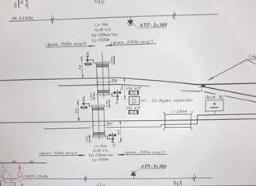
Existing signaling box (Strelochniy Perevod)  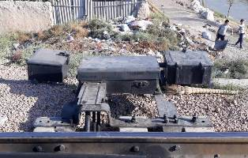 | Proposed signaling box (Strelochniy Perevod)
- The following methods for the social due diligence have been applied during the previous reporting period to confirm the LAR absence for the abovementioned stations: (i) desk review of design documentations, particularly ensuring that the final boundary of detailed design is included in existing limits of railway operation, (ii) conducting of walkover survey to be sure that dismantling and replacement of the existing equipment with new one is reliable to implement without additional impact.
- Design change: Due to installation of sectioning post buildings and access roads, the permanent land has been required for the construction of 2 new section posts in Uychi-Chartak (PK1194+00). The second post sectioning Chust-Turakurgan direction (PK635+35) is located within the RoW of the existing railway road Pap-Namangan-. This design change has been finalized at the end of December 2019.
- In total 0.24 ha arable land is permanently affected due to the construction of two sectioning posts. The number of affected land users due to loss of permanent land acquisition is only 1 AH with 7 APs (AH members). According to impact assessment, the AH is not severely affected and as well as not vulnerable. There is no impact on structures, trees, business and employment.
- The Addendum to LARP 1 with respective LAR impact and budget has been sent to ADB for review and approval on 19.03.2020. The ADB comments on Addendum is received on 02.09.2020. The report has been reviewed and finalized at the end of 2020. The approval of LARP 1 addendum including of compliance report on its implementation is expected in the next reporting period.

Next Steps
Table 1. Main activities planned for this component for the next reporting period
No | Activity | Responsible Party | Targeted Timeline
1 | Payment of compensation for registration cost to 1 AH | PIU/UTY | as of 31 December 2021
2 | Approval of Addendum to LARP 1 including monitoring compliance report for construction of 2 new section posts | PIU/UTY/ADB | Beginning of February 2021
- COMPONENT 2: CONSTRUCTION OF TWO NEW TRACTION SUBSTATIONS IN NAMANGAN (RAUSTAN AND KHAKKULABAD, INCLUDING THE ACCESS ROADS)

LARP Preparation and Approval
- The implementation-ready Land Acquisition and Resettlement Plan (LARP) has been prepared by UTY for one of the components of the “CAREC Corridor 2 (Pap-Namangan-Andijan) Railway Electrification Project”: construction of 2 traction substations in Raustan and Khakkulabad (including the access roads), financed by ADB to assess the land acquisition and resettlement impacts of the project based on the final design in accordance with requirements of relevant Uzbek laws and regulations and ADB’s SPS 2009. The map of the traction substations is provided in Figure 4. The LARP has been approved by ADB in September 2018 and has been disclosed on ADB’s and UTY’s websites.
Figure 4: Map of the traction substations in Raustan and Khakkulabad
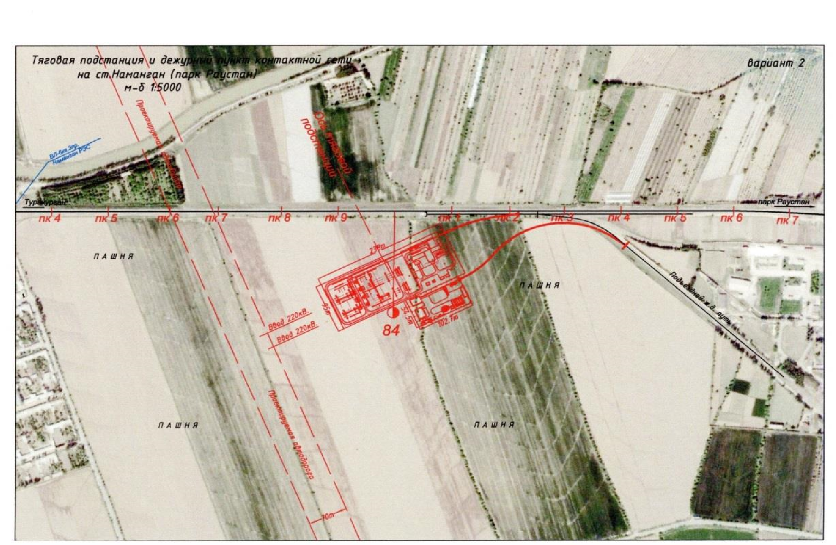
- The impact of the project in terms of land acquisition is limited to two districts of Namangan and Norin. The project has only permanent impacts in terms of land acquisition. Permanent land acquisition includes loss of land permanently required for the construction of proposed two new traction substations. In total 8 land parcels with 11.8 ha area is permanently affected due to the project, of which 5 land parcels (6.5 ha) in Namangan and 3 (5.3ha) in Norin districts. The number affected land users due to loss of permanent land acquisition is 6 in 5 AHs (2 land users are from the same AH). The project has impacted 4 agricultural lands hold by 3 farms (leaseholder) and 1 dekhan with total area of 10.51 ha. The other affected non-agricultural land plots with total area of 1.29 ha are reserve lands or city land used for roads, ditches, channels with no agricultural impacts. Out of totally affected 11.8ha lands a total of 10.51 ha (90%) of agricultural land is affected which is used as arable/crop cultivation land for various types of crops such as wheat, cotton and alfa alfa. A total of 13 number of trees will be affected due to permanent acquisition of non-agricultural lands (part of irrigation land using for channels/ditches). All affected trees are wood trees planted by the not-registered users along the irrigation channels. There aren’t impacts on structures, business and employment. The total number of AHs is 5 with total number of 35 APs. According to impact assessment, there is only one vulnerable AH in Norin district, while there are 2 AHs severally affected by the project (10.41% and 19.23%) due to permanent land acquisition.

LARP Implementation
- LARP implementation has actually started at the beginning of October 2018. UTY (PIU) immediately finalized preparation of the relevant documentation for further payment of compensations to the farmers affected under the Traction Substation Raustan and Khakulabad according to the LARP and ADB SPS.
- Upon the completion of LARP preparatory actions, the notification letters to each AH regarding the defined compensation amount has been carried out by UTY on 13-14 of November 2018. As a result of LARP implementation, in total compensation of 194,490,475.9 UZS has been paid to 3 AHs as defined by LARP. To accelerate the compensation payment procedure, PIU representatives and consultants visited each AH to collect the bank accounts, in order to transfer directly to AHs UTYs finance department required to get transfer request letter by AHs. Meantime, in regard with land for land compensation(Raustan), agreement letters were provided by “Gulnora” and “Anor” farms indicating that they do not have any necessity for extra land (instead of affected land 4.9 ha and 0.56 ha respectively) only in case if fully compensation is provided for crop losses (compensation has been provided on 13 of November 2018). While for the Khakkulabad, there were Norin district khokims decision #507 dated 24 of March 2018 about allocating the extra 8,6 ha land instead of 5 ha affected land) from the khokimiyats reserve land to “Gulchehra Mamadjanovna” farm which is located in Tashkent massive in Norin district.
- ADB consultant prepared a completion report, which provides all the details regarding LARP implementation process and its compliance to the SPS and LARP. The Completion Report for LARP 3 has been approved in November 2018 and disclosed on ADB website on 5 December 2018.

Unforeseen Impact
- The unforeseen impact has been identified in TSS of Khakkulabad during the ADB’s mission in September 2019. In general, 22 polls have been already installed, out of which 5 are included in and 17 polls with 9 support foundations are out of LAR boundary covered by LARP 3. The official land allocation data has been received from Cadaster the land allocation and impact assessment survey conducted in March 2020. The impact assessment survey for was carried out based on the final design for extension for traction substation Khakulabad. Based on the impact assessment data the affected land plot is arable with affected surface area of 0.8ha (indicated by green line in Figure 5) out of which 0.24 ha is under cultivation of alfa-alfa by 1 AH. Based on verified data provided by khokimiyat, the AH has been considered as elderly headed household. The AH is not severely affected as don’t lose 10% and more agricultural income and is not physically relocated.
- The mentioned LAR impact with respective budget has been reflected in Addendum to LARP 3 prepared in April 2020. The Addendum was approved by ADB on 15 September 2020. The implementation of Addendum is completed. In total the AH received 107,203,615.39 UZS compensation, out of which 184,615.39 UZS rehabilitation allowance were paid through bank transfer on 23.12.2020. The completion report is expected to be prepared during next reporting period.

Figure 5: Map of the traction substations in Khakkulabad with indication of Polls
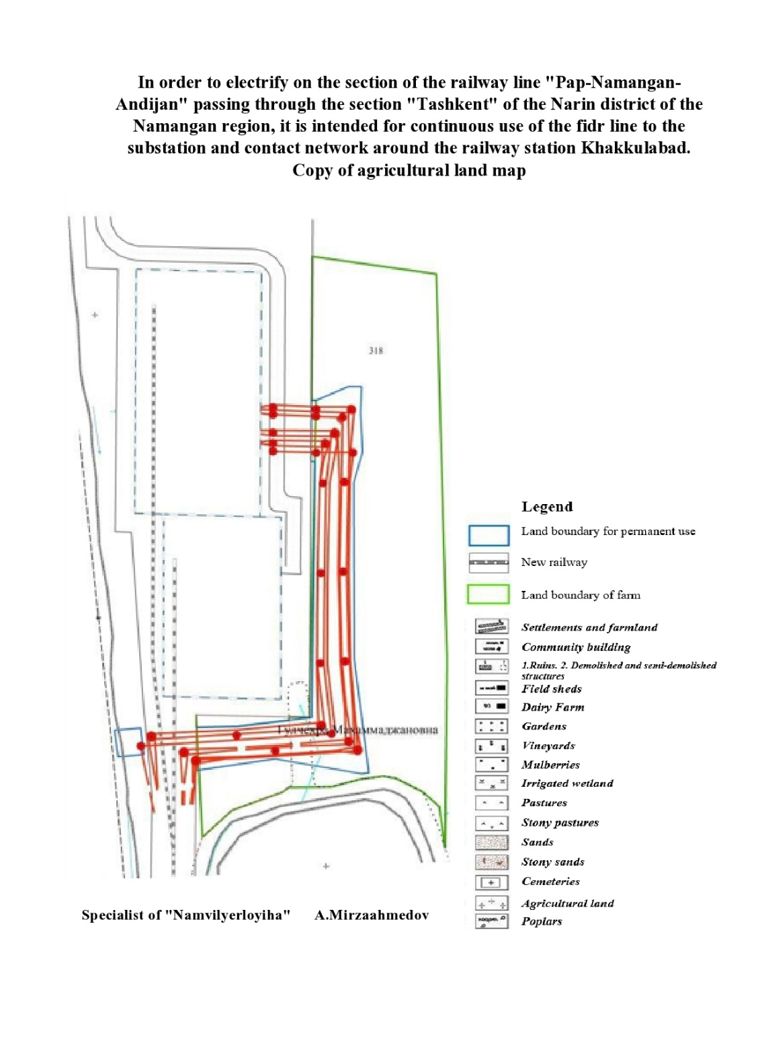
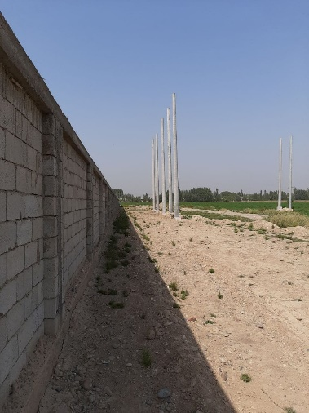  5 polls are in RoW | 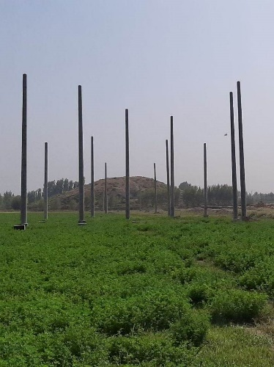  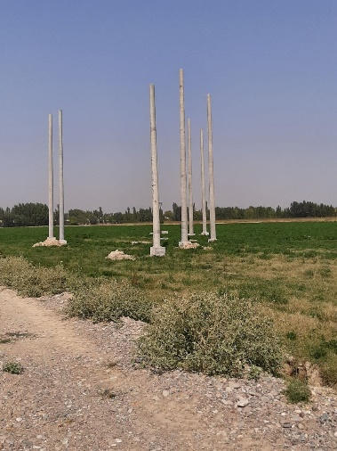  17 polls and 9 support foundations are out of RoW

- COMPONENT 3: EXTERNAL POWER SUPPLY TRANSMISSION LINE (TL) OF 52KM
- Due to delay of obtaining land allocation document for Khakulabat it was agreed with ADB to prepare 2 separate LARPs under this particular component: LARP 2.1 covered 220 kV for Raustan (12km) and LARP 2.2. for Khakkulabad (40km).

Approval of LARP 2.1
- The LARP 2.1 for Raustan (12km) has been prepared in June 2019 and approved by ADB on 14.10.2019 and disclosed on ADB and UTY’s website. The impact of the project in terms of land acquisition is limited to two districts: Turakurgan and Namangan districts and Namangan city. The project will have permanent and temporary impacts in terms of land acquisition. Permanent land acquisition includes loss of trees as well as permanent impacts on agricultural land within the permanent area for installation of suspension and anchor angular towers, while temporary land acquisition with the RoW includes loss of land required temporarily during construction of reinforced concrete and suspension and anchor angular towers and installation of external power supply cable which will cause of loss of trees and agricultural land due to the construction.
- In total 36.28 ha (1.16 ha permanent and 35.12 ha temporary) area is permanently and temporary affected due to the project, of which 0.99ha permanent and 27.96 ha temporary affected agricultural cultivated land and 0.16ha permanent and 6.45 ha temporary affected orchard/garden land. The number affected land users due to loss of permanent and temporary land acquisition are 50 AHs with 317 APs (AH members). A total of 1764 numbers of fruit trees are affected due to permanent and temporary acquisition. All affected trees were evaluated by independent appraisal company while the annual harvest evaluated by agriculture department of local khokimiyats. There is a temporary impact for unregistered movable greenhouse which will be dismantled and removed temporary during the construction period of 2-3 weeks in that section. No business and employment is impacted by the project.
- The total number of AHs is 50 with total number of 317 APs. According to impact assessment, there are no severely affected HHs due to permanent land acquisition, as well as no vulnerable AH affected by the project.

Implementation of LARP 2.1
- The LARP implementation has started in at the end of September 2019. At the end of June 2020, only compensation for trees has been transferred to the Bank accounts of 30 AHs with total amount of 137,616,025.00UZS and compensation for loss profit with total amount of 357,664.00UZS to 14 AHs. The payment of the remaining compensation for land development and loss of harvest from trees has resumed in November-December 2020 and will be completed at the end of January 2021. The Compliance Report will be prepared and submitted for ADB’s review and approval once the LARP implementation is completed.

Preparation and Approval of LARP 2.2
- The detailed design of 110 kV Khakkulabad (40km) is finalized and the signed version is provided to UTY in February 2020 by UzbekEnergo. The DMS data has been obtained from the Cadaster Committee and the land allocation data for all affected districts has been obtained from Khokimiyat in the middle of June 2020. Besides, the khokimiyat’s decision on land allocation in the Izboskan district of the Andijan region had made. The decision from all four khokimiyats for the construction of an external power supply line to the Khakkulabad traction substation has been obtained as well. Due to covid19 restrictions Census and SES has been only carried out with 55% of AHs/APs by phone call.
- The LARP has been prepared on 15.09.2020 and approved by ADB on 15.10.2020. The impact of the project component in terms of land acquisition is limited to four districts: Uychi, Uchkurgan, Norin districts (Namangan province) and Izboskan districts (Andijan province). The project component has permanent and temporary impacts in terms of land acquisition. Permanent land acquisition includes loss of trees as well as permanent impacts on agricultural land within the permanent area for installation of suspension and anchor angular towers, while temporary land acquisition with the RoW includes loss of land required temporarily during construction of reinforced concrete and suspension and anchor angular towers and installation of external power supply cable which is caused of loss of trees and agricultural land due to the construction.
- In total, 59.527 ha (0.747 ha permanent and 58.275 ha temporary) is affected. This comprises 0.606 ha of permanent and 47.191 ha of temporary affected agricultural cultivated land; 0.112 ha of permanent and 7.52 ha of temporary affected orchard/garden land; and 0.03 ha of permanent and 3816 ha of temporary ditches, canals, roads, cemetery and other lands. A total of 1674 fruit trees are affected. There is temporary impact on 1 registered barn brick fence and 2 unregistered movable greenhouses which will be dismantled and removed temporarily during the construction period of 2-3 weeks in that section. A total of 121 agricultural land users are affected. According to impact assessment, there aren’t severely affected APs and vulnerable AHs affected by the project. No business and employment is impacted by this component of the project as well.

Implementation of LARP 2.2
- The land acquisition and resettlement cost for the project includes eligible compensation cost for LARP implementation as per the entitlement matrix. Compensation by the project included loss of land development cost to make the replaced land usable, loss profit from affected land, loss harvest from trees, cost of affected trees. Total Indicative cost land acquisition and resettlement is 559,652,051 UZS equivalent to 54,471.753 USD.
- The LARP implementation in December 2020 and will be completed at the end of February 2021. The Compliance Report will be prepared and submitted for ADB’s review and approval once the LARP implementation is completed.

- COMPONENT 4: ASSOCIATED FACILITIES

Electrification of The 27.5 Kv Transmission Lines for the New Alignment of 6.7 Km
- Constructed new track starts from km 125+700 (Uychi station) to km 132+400 (Khakkulabad), the route runs along a new direction of length 6.7 km. Rectification will diverse the railway line to the border with the Republic of Kyrgyzstan that currently is creating difficulties with track maintenance in term of accessing to the territory of neighboring country.
- From the point of unlocking the railway track with 620 m radius extends to the right and passes irrigated lands on the PC 1272 + 22 crosses the North Fergana Canal (NFC). Before the NFC railway track crosses the highway. Right Bank Canal is densely populated residential area and partially will be resettled. Tunnel type overpass 96,61m length will be constructed to cross highway. Construction of concrete bridge length of 64.6 m is planned for crossing the NFC. An automobile road runs along the left bank of the NFC and railway overpass length of 53.2 m will be constructed to cross it. Then the railway route comes to the Naryn River, which is one of the main water sources of the Ferghana valley. Naryn river splits into two branches at the project area. It is proposed to build concrete bridge over right branch (length 270.80 m). The left branch will be reverted into the right branch through construction of dams. The left branch of NFC and flood plain will be passed by construction railway embankment. Further railway track passes irrigated land and at point PC 1295 + 34.5 crosses Hakulabadsay (smaller canal) concrete bridge length of 57,5m will be constructed to cross it. At the point PC 1297 + 35.5 railway track crosses the South Fergana Canal (SFC), by construction of concrete bridge length of 64.6 m. Then the railway track route passes through farmland and at the point PC1311 crosses highway 4R116. A railway overpass length of 53.2 m will be built for intersection railway with automobile road. Further 600 m radius of the track of the railway line adjacent to the checkpoint at the PC 1361 of the existing railway line. At the intersections of railway with smaller roads, at the PC in 1296 and + 82 + 45 PC 1301 protected and unprotected passes will be constructed. A scheme of new alignment is provided in Figure 6.
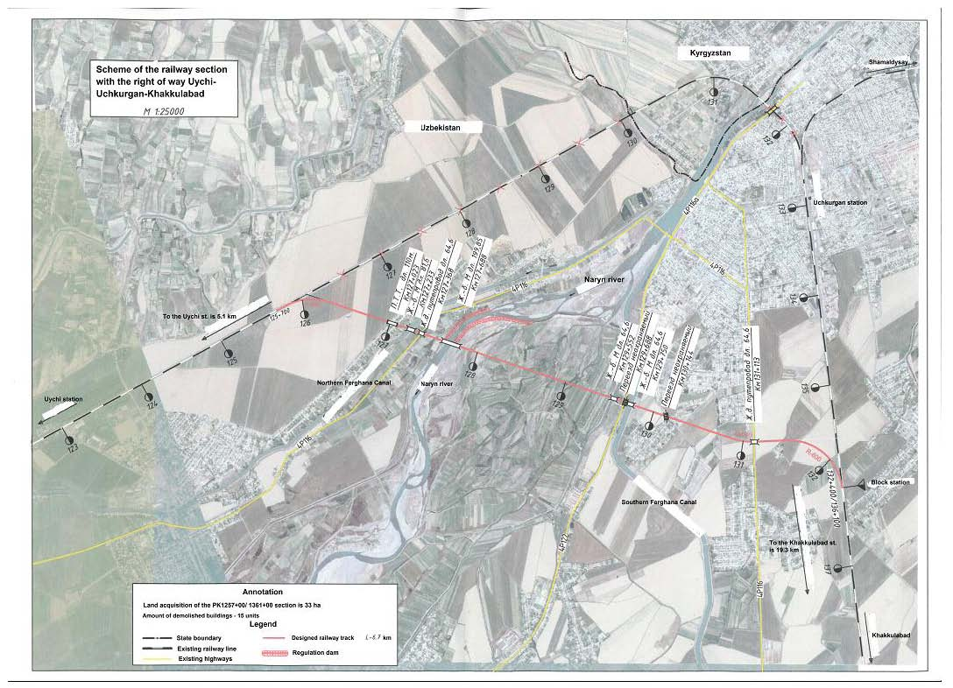
Figure 6: Location of 6.7 km bypass

- The new alignment (6.7km) traverses through Uychi and Uchkurgan destricts of Namangan Province and passes mostly through agricultural lands and some parts of residential area (Kizil Ravat village and Uchkurgan city) affecting 13,96 ha of land plots, of which 12,22 ha are farm lands, 2 non-residential buildings and relocation of 25 residential houses.
- In this regard, land allocation procedures have been initiated by UTY and khokimiyats according to the national legal requirements based on which in total 2.45 (residential) and 0.246 (non-residential) lands have been allocated by khokimiyats for the persons losing buildings.
- According to the District Decisions by Uychi and Uchkurgan Khokims, in total 13,96 ha of land plots will be affected by the Project, of which 12,22 ha of agricultural land plots (farmland) used by 9 users. Meantime, there are in total 25 residential and 2 non-residential buildings to be demolished, of which 8 houses (13 households) are located in Uychi district and 17 houses and 2 non-residential buildings are located in Uchkurgan district. The total number of AHs is 41.
- The land allocation has been completed both in Uychi and Uchkurgan and compensation is paid. All the affected structures were demolished within March-May-2018. Pending Completion Report will be submitted to ADB during the next reporting period.

New passing loop at 137km (Uychi Block Post)
- This component of associated facilities is already covered by the original SDDR which was approved and disclosed on ADB website in February 2017. Actually, the construction of Uychi Blok post was not covered by the original SDDR due to lack of ready design, that’s why this Addendum to original SDDR has been prepared for Construction of Uychi Blok post
- Construction of the automobile road for Uychi Blok Post (passing loop) distance from PK-1311+50-PK-1319+30 (780 m distance);
- Borrow pit for construction in PK-1320+30-PK-1321+50 (120 m distance);
- Building of Uychi Blok Post (passing loop) in PK-1360+00.
- The final design for Uychi Blok Post (passing loop) has been prepared and approved on 8 April 2017. The construction works was started in January 2019 in Jalaobod and Kuchkorota massives Uchkurgan district. The construction works have been conducted on the basis of the Boshtransloyikha final drawings and Uzdaverloyihka Namangan branches land allocation document.
- For the construction of Uychi Blok Post the land plots are affected for which land allocation procedure has been already initiated by UTY and khokimiyats and applied in accordance with national legal requirements. For this purpose, the resolution No1489 of the Governor of Uchkurgan district of Namangan region has been made on 15.12.2018.
- There is only two massive which is affected due to the permanent and temporary land acquisition
- Permanent impacts: Permanent land acquisition includes loss of farmland required for:
- Construction of the automobile road for Uychi Blok Post (passing loop) distance from PK-1311+50-PK-1319+30(780 m distance);
- Borrow pit for construction in PK-1320+30-PK-1321+50 (120 m distance);
- Building of Uychi Blok Post (passing loop) in PK-1360+00.

- Temporary impacts:
- Partly for the component building of Uychi Blok Post (passing loop) in PK-1360+00 and Borrow pit for construction in PK-1320+30-PK-1321+50 (120 m distance).
- According to the final drawings and land allocation document there are total 7.61ha land (3.16 ha permanent and 4.45 ha temporary) which belongs to 3 AHs affected in Uchkurgan district. There aren’t non-residential buildings affected by the project. Out of totally affected 7.61 ha lands a total of 7.06ha (92.78%) are Arable/Crop cultivation including the 0.25 ha land for ditches, 0.55 ha (7.22%) are khokimiyat reserve lands. Moreover, there are no garden and no trees affected by the Project. 6.81ha crops, namely corn and cotton/wheat are affected due to land acquisition. In general, 3 households are affected.
- All three AHs have received full compensation amounts to 11,744,102 UZS, which has been transferred by UTY to AHs bank accounts in April 2019. The verification of the Addendum’s implementation is confirmed by the monitoring conducted by social safeguard specialists of Supervision Consultant, which is compliance to the ADB SPS and Addendum to SDDR.
- The Addendum to SDDR has been approved and disclosed on ADB website on 24 September 2020.

Annex 1: List of DDR sections under LARP 1 with chainages
Name of the section | Name of station | KMs | Targeted Timeline
Signaling box (Strelochniy Perevod) | Andijan 1 to Andijan 2 including Harabek | PK 3260+06 | February 2021
 | Pap 1 and Pap 2 | PK 453+45
Sectioning post | Uychi-Chartak | PK1194+00 | February 2021
 | Chust-Turakurgan direction | PK 635+35
DSF

Annex 2: LAR Impact Summary Data Per Implemented LARPs
No | Type of Impact | LARP 1 | LARP 3 | LARP 2.1 | LARP 2.2
1 | Number of affected land parcels | 16 | 8 | -
2 | Total Affected Land area (ha) | 0.16 | 11.8 | 36.28 | 58,527.75
3 | Affected agricultural cultivated land area (ha) | - | 10.51 | 35.57 | 47,199
4 | Affected Non-agricultural land area (ha) | - | 1.29 | 0.71 | 3.85
5 | Residential land (ha) | 6 | - | - | -
6 | Number of severely AHs (lose of ≥10% agricultural impact) | - | 2 | - | -
7 | Number of severely AHs (physical displacement) | 2 | - | - | -
8 | Number of vulnerable AHs | 6 | 1 | - | -
9 | Number of affected residential structures | 85 | - | - | -
10 | Number of affected non-residential structures | - | - | 1 | 3
11 | Number of affected businesses | - | - | - | -
12 | Number of affected employees | - | - | - | -
14 | Number of affected fruit trees | 27 | - | 1764 | 1599
15 | Number of affected wood trees and bushes | 15 | 13 | - | 1015
16 | Number of total AHs | 16 | 5 | 50 | 158
17 | Number of total APs | 119 | 35 | 317 | 705

Annex 3. Summary Status of Safeguards Documentation and Implementation per Project Components
Safeguards Document | Project component | Social Safeguards preparation Status | Implementation and Reporting Status
LARP 1  (16 AHs/ 119 APs, o/w 2 AHs relocated) | Electrification of 145.1km of railway track between 5.2 km east of Pap Station and Andijan 1 station | LARP implementation is completed. All compensation, rehabilitation allowances have been paid to APs, land allocation for 2 AHs is completed. | The Completion Report (CR) has been approved and disclosed on ADB website on 19 May 2020.
Scope change: | New signaling sections from Pap1-Pap2, Andijan1-Andijan 2 | Social due diligence information included in the SSMR for Jan-June 2019. | SSMR has been finalized based on ADB comments and approved.
Design change | 2 new section posts in Chartak-Uychi and Chust-Turakurgan sections of the main track | Addendum to LARP 1 has been reviewed and finalized at the end of 2020. | The approval of Addendum will be in January 2021
LARP 2.1  (50 AHs/ 317APs) | External Power Supply line to/from Raustan  (220 kV TL, 12 km)) | LARP Implementation completed except of compensation for trees/crops and allowances. Budget allocation by UTY is pending. | Completion Report to be finalized once full compensation is paid.
LARP 2.2  (not-yet known) | External Power Supply line to/from Hakkulabad  (110 kV TL, 40 km) | The LARP has been approved by ADB on 15.10.2020. | Completion Report to be finalized once full compensation is paid.
LARP 3  (5 AHs/ 35APs) | Two traction substations at Raustan and Hakkulabad | LARP Implementation completed in 2018. | LARP Completion Report disclosed in Nov 2018.
Additional land has been used which was not covered by LARP | Hakkulabad traction substation | The Addendum was approved by ADB on 15.09.2020 | Completion report will be prepared in February 2021
Associated facilities | - New alignment of 6.7 km,  - new block post (loop) at km 137 | SDDR disclosed in Feb 2017 (6.7km bypass).  The Addendum to SDDR is approved on 24.09.2020 | - Pending Completion report for 6.7km. (expected in February-March 2021).  - The Addendum to SDDR is approved and disclosed on ADB website

Annex 4. Payment Order of Compensation for Registration Cost
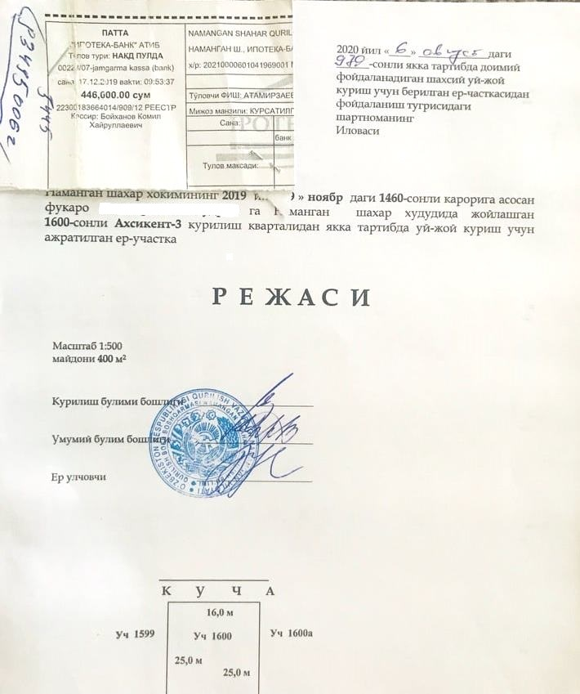

The Social Due Diligence Report (SDDR) has been prepared for associated facilities subject to implementation and monitoring by UTY.
According to the OM F1 “The involuntary resettlement impacts of an ADB-supported project are considered significant if 200 or more persons will experience major impacts, which are defined as (i) being physically displaced from housing, or (ii) losing 10% or more of their productive assets (income generating).
https://www.adb.org/sites/default/files/project-documents/48025/48025-003-rp-en_1.pdf, http://railway.uz/ru/informatsionnaya_sluzhba/novosti/15735/
http://railway.uz/ru/informatsionnaya_sluzhba/novosti/15735/
http://lex.uz/docs/4182204, Chapter 2, para 6
https://www.adb.org/projects/documents/uzb-48025-003-smr-4
This was identified and reported in the previous SSMR for Jan-June 2019.
https://www.adb.org/sites/default/files/project-documents/48025/48025-003-rp-en_0.pdf
https://www.adb.org/sites/default/files/project-documents/48025/48025-003-smr-en_1.pdf
https://www.adb.org/projects/documents/uzb-48025-003-rp-3
https://www.adb.org/projects/documents/uzb-48025-003-rp-4
https://www.adb.org/sites/default/files/project-documents/48025/48025-003-sddr-01.pdf
https://www.adb.org/projects/documents/uzb-48025-003-sddr

